Intro to SQL Programming

1.Ask Database for Table Data 2

1.1 Downloading, Installing and Opening the DB Browser 2

1.2 Asking for Data with the SELECT Clause 6

1.3 Narrowing down query results with the WHERE Clause 10

1.4 Displaying query results with the AND/OR Conditions 12

1.5 Limit the # of records displayed as the query results 14

1.6 Organize Query results with the ORDER BY Keyword 15

1.7 Viewing Different Query Results by using Length, Count & Distinct keywords 17

1.8 Chapter Quiz 21

2.Ask Database for 2 or 2+ Tables Data 22

2.1 Ask for Data across two or more tables 23

2.2 Understanding JOIN Types for combining tables 25

2.3 Combined Results 27

2.4 Chapter Quiz 29

3.Data Types, Math & Inbuilt Functions 30

3.1 Data Types 30

3.2 Subquery 31

3.3 Chapter Quiz 35

4.Ask Database to add or modify data 36

4.1 Add data to a table 36

4.2 Updating data in a table 37

4.3 Remove data from a table 38

4.4 Chapter Quiz 39

39

5. Conclusion 40

5.1 List of Common SQL Mistakes 40

5.2 Chapter Quiz 40

# 1.Ask Database for Table Data

## 1.1 Downloading, Installing and Opening the DB Browser

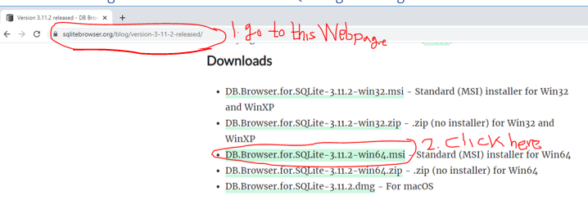

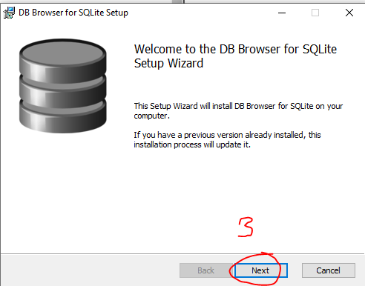

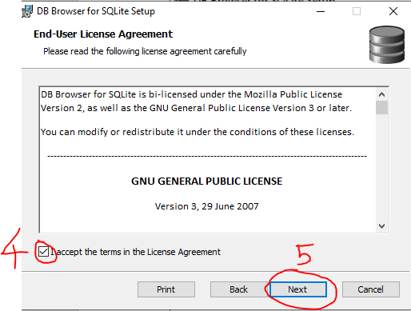

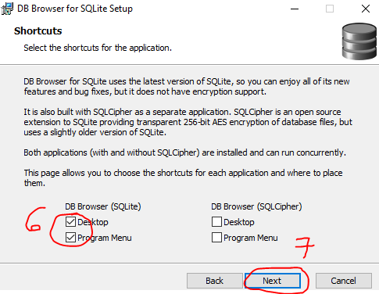

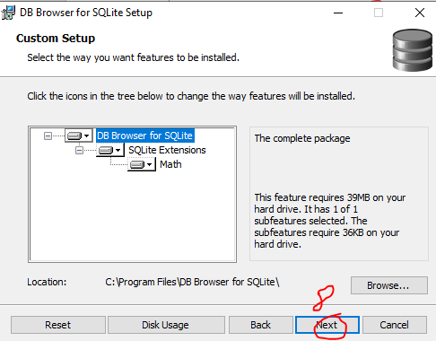

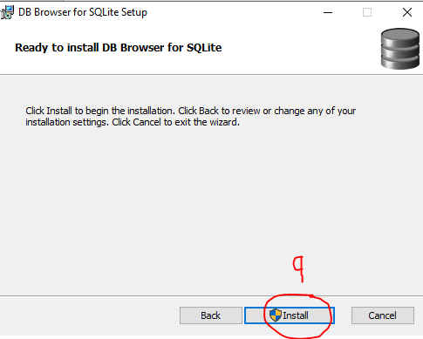

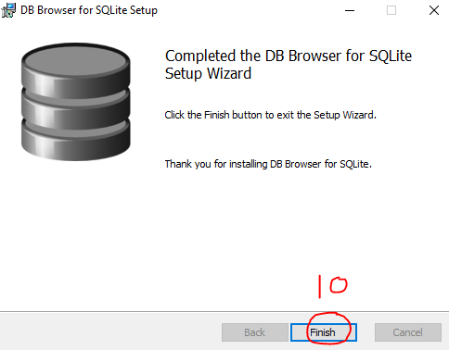

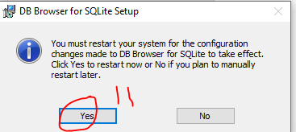

## 1.2 Asking for Data with the SELECT Clause

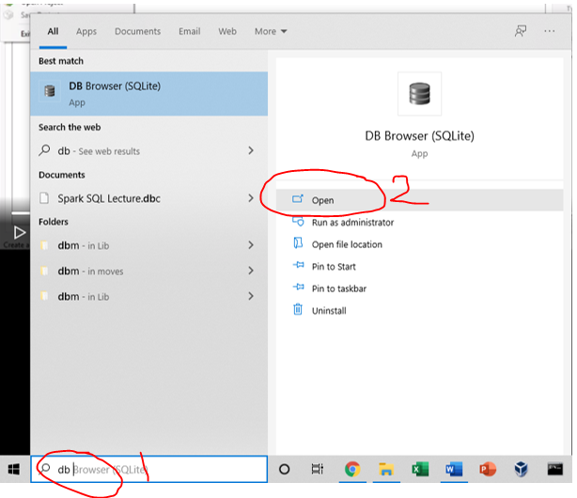

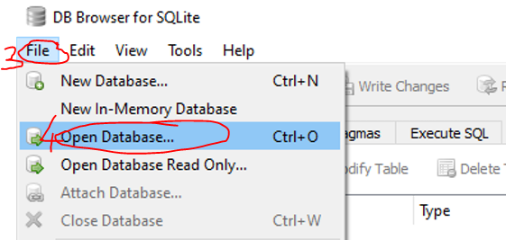

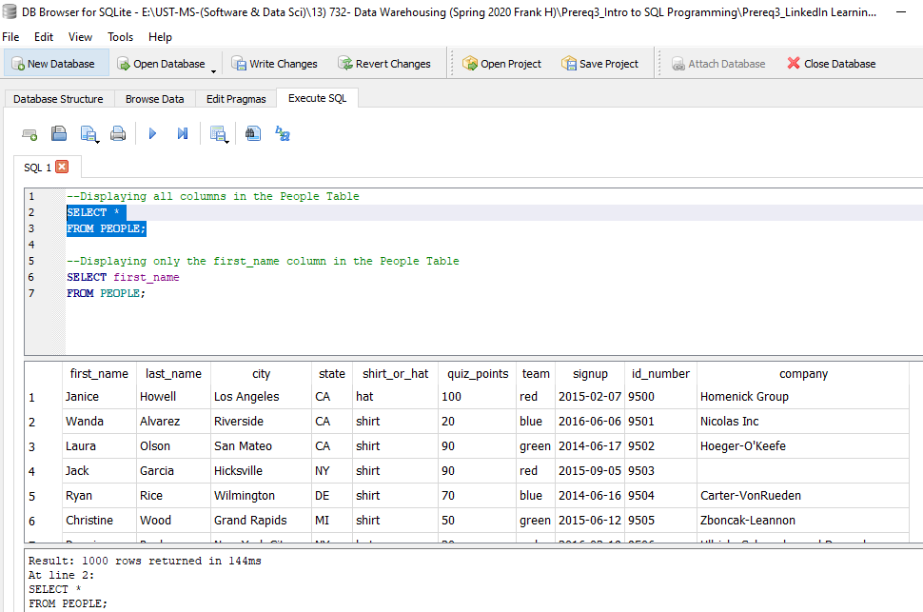

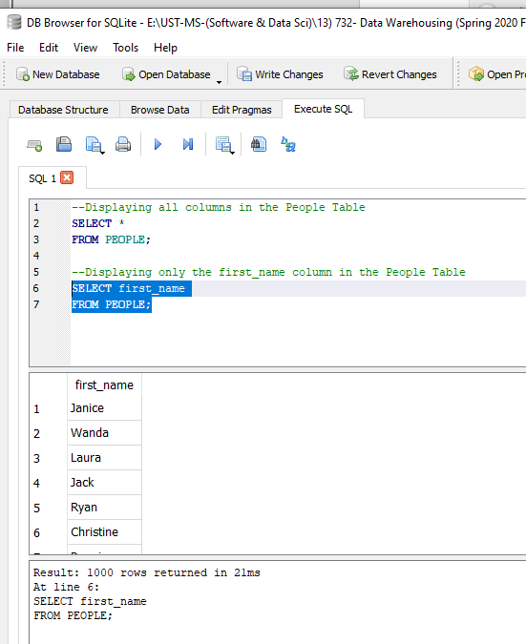

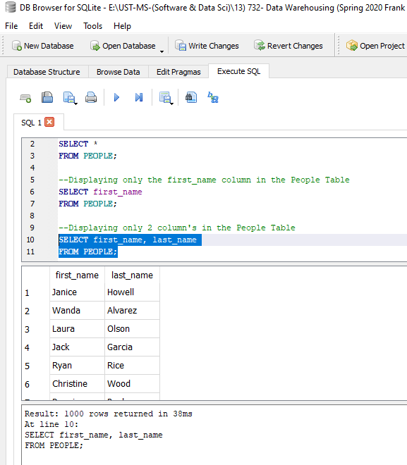

## 1.3 Narrowing down query results with the WHERE Clause

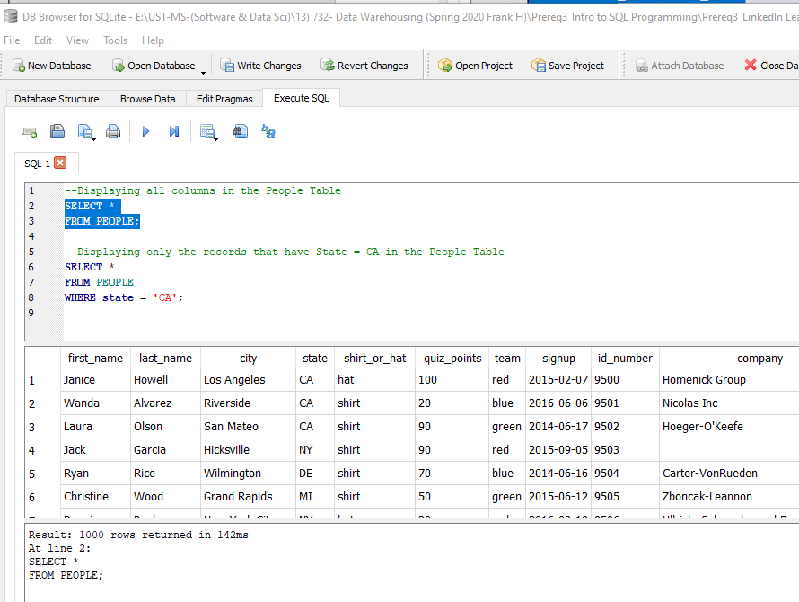

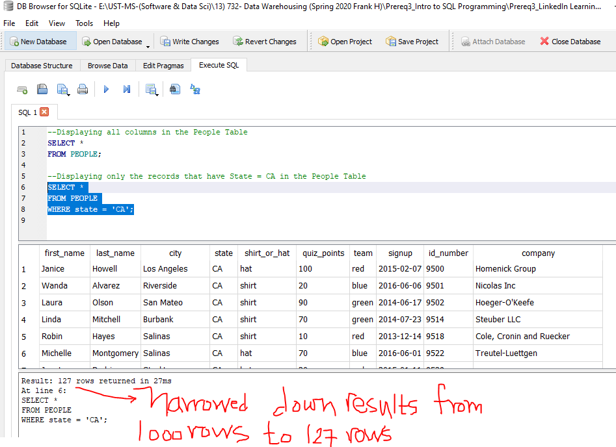

## 1.4 Displaying query results with the AND/OR Conditions

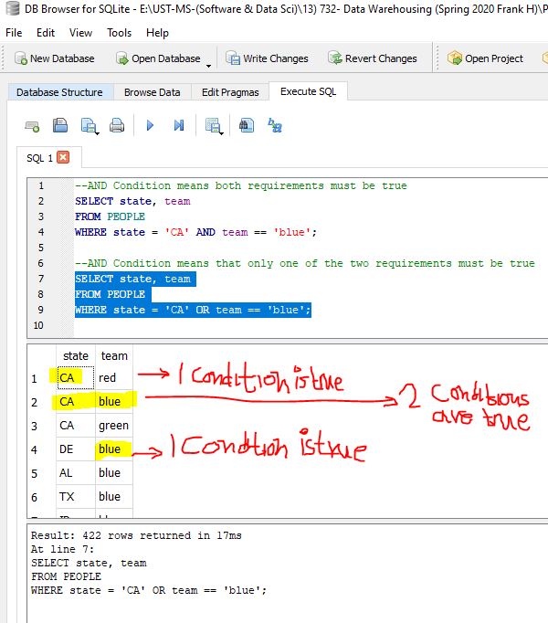

## 1.5 Limit the # of records displayed as the query results

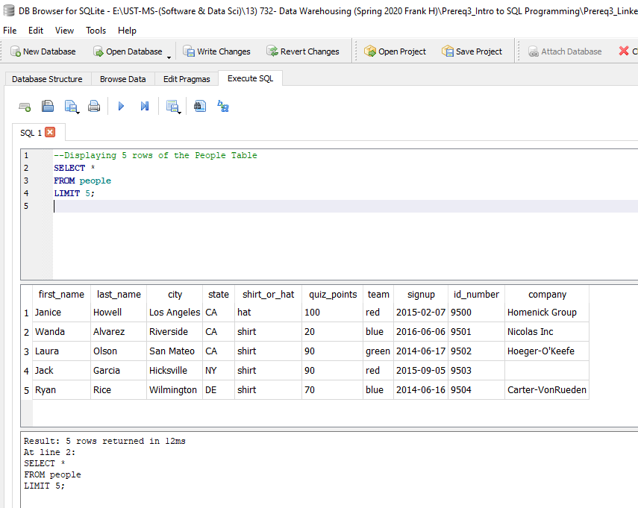

## 1.6 Organize Query results with the ORDER BY Keyword

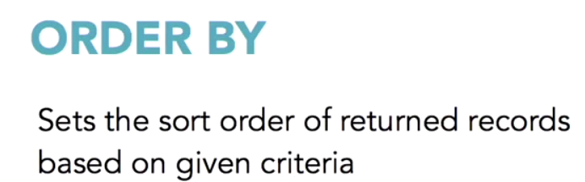

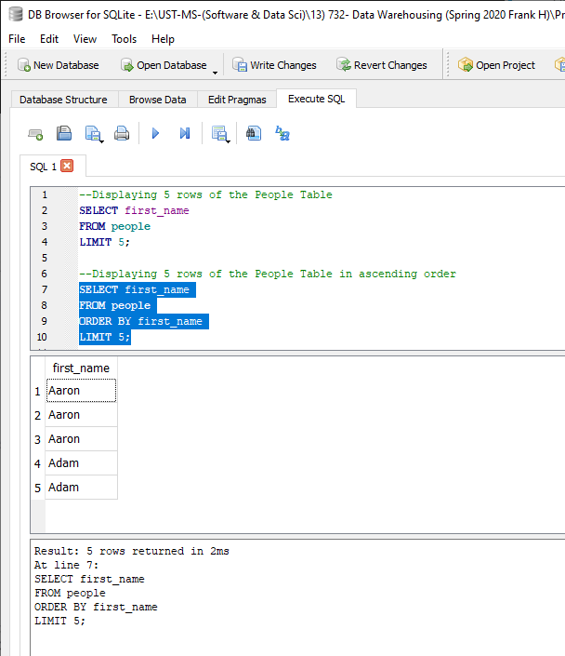

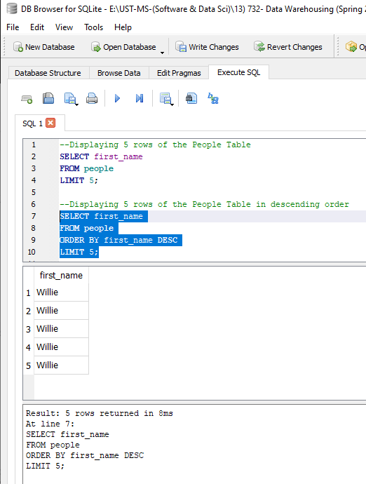

## 1.7 Viewing Different Query Results by using Length, Count & Distinct keywords

## 1.8 Chapter Quiz

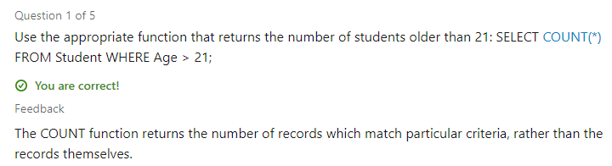

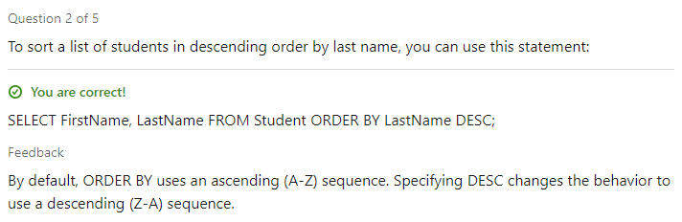

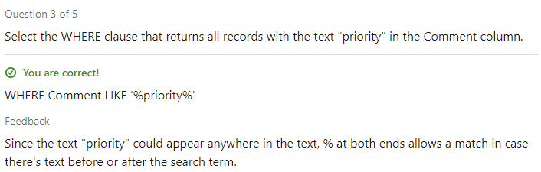

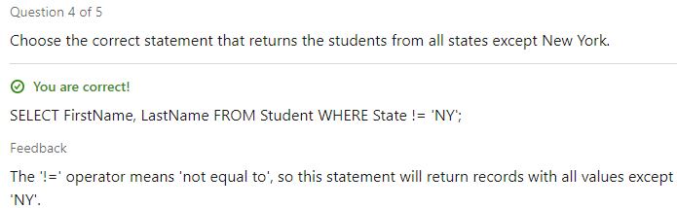

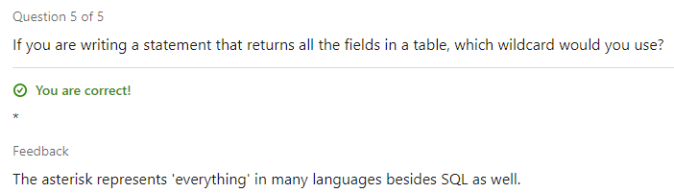

# 2.Ask Database for 2 or 2+ Tables Data

## 2.1 Ask for Data across two or more tables

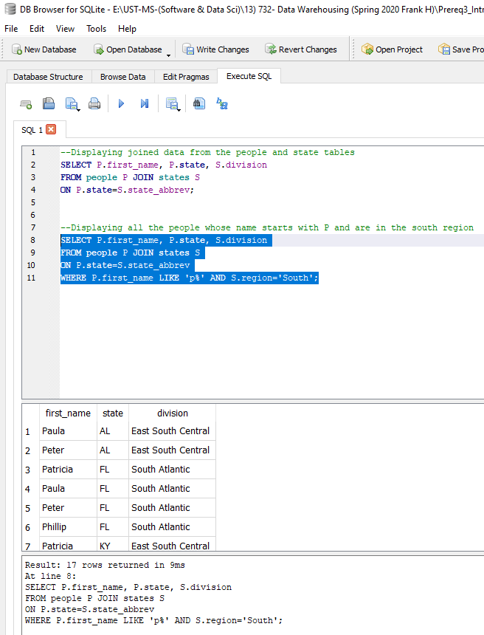

## 2.2 Understanding JOIN Types for combining tables

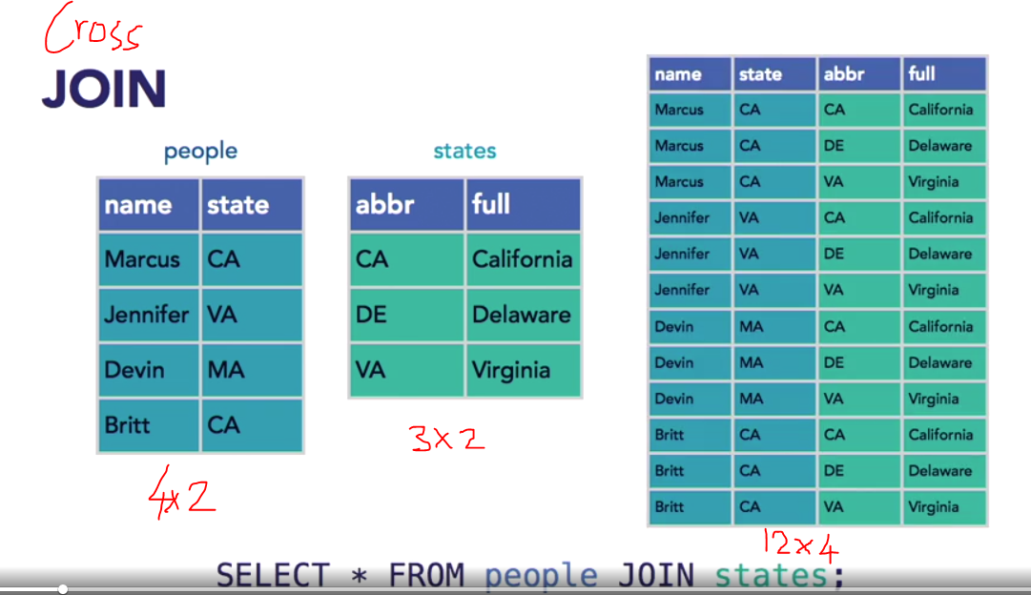

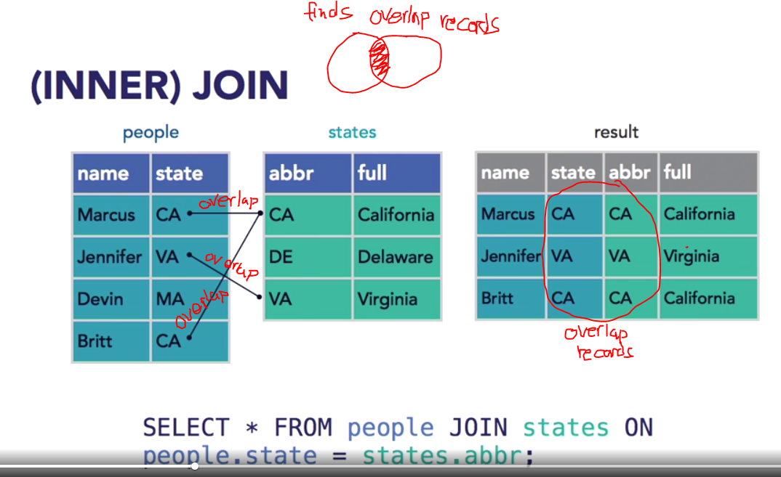

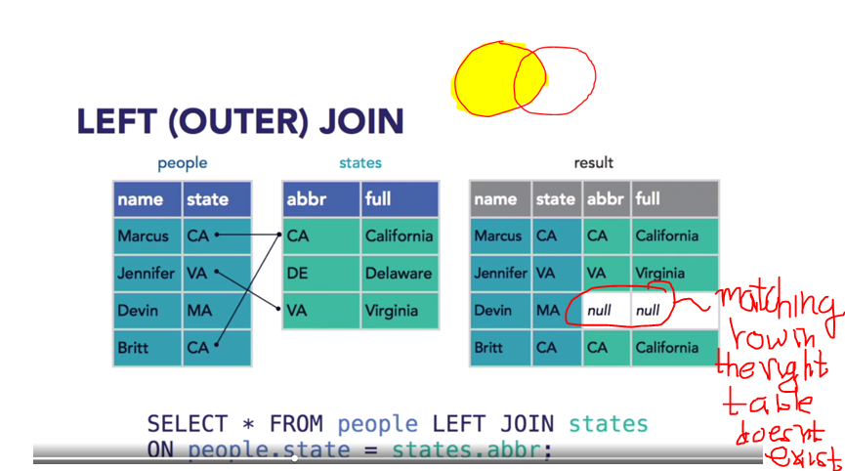

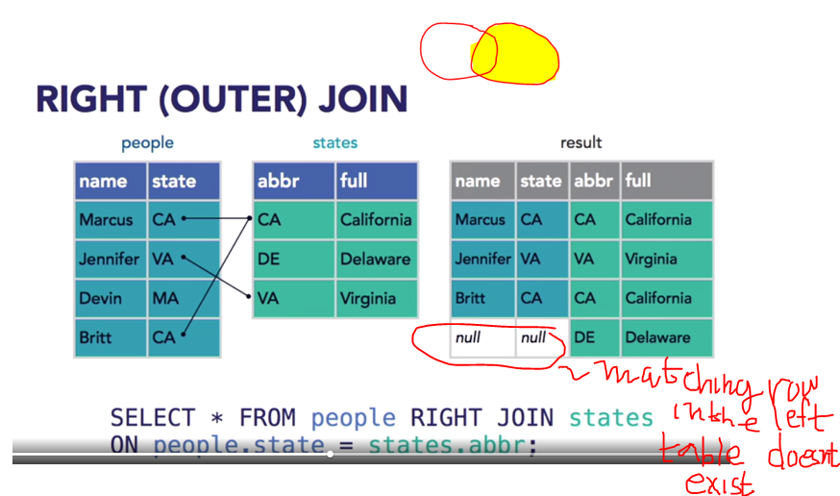

## 2.3 Combined Results

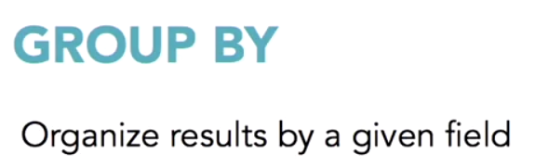

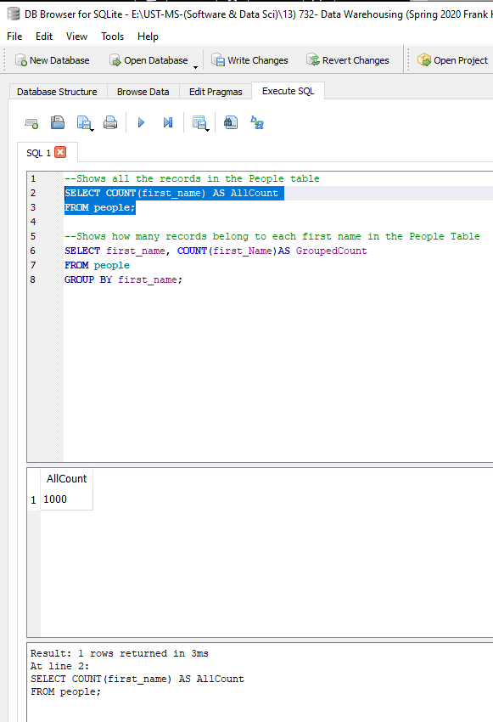

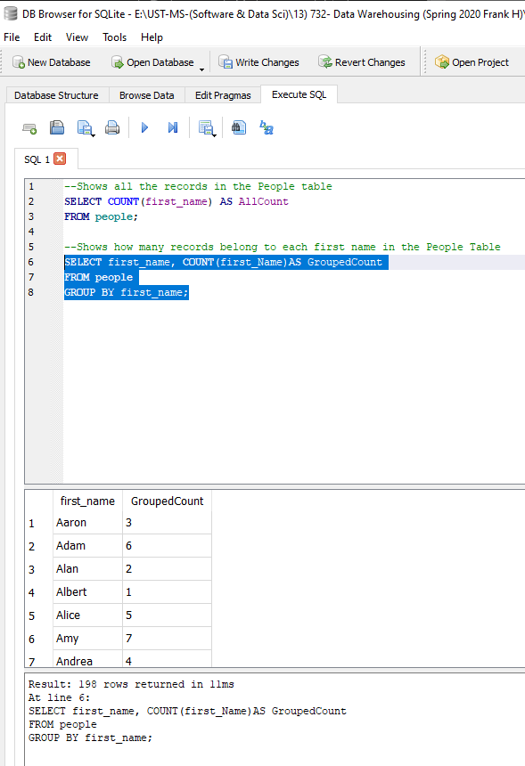

## 2.4 Chapter Quiz

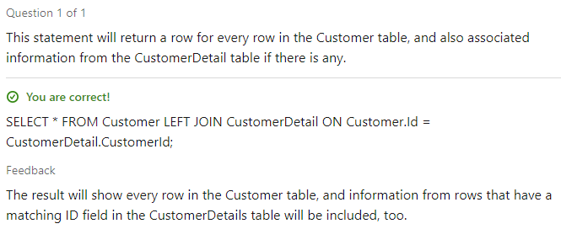

# 3.Data Types, Math & Inbuilt Functions

## 3.1 Data Types

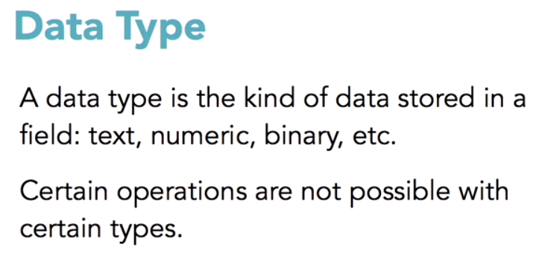

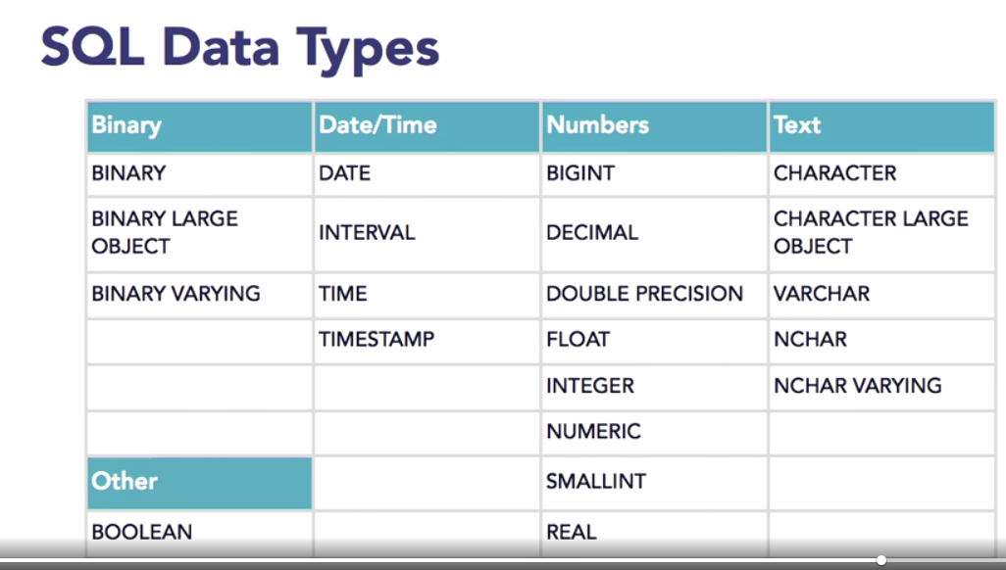

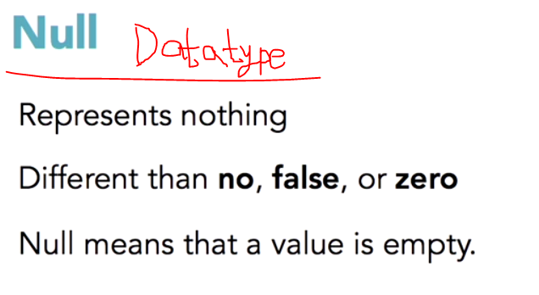

## 3.2 Subquery

A subquery is a query that is nested inside a SELECT, INSERT, UPDATE, or DELETE statement, or inside another subquery.

A subquery is also called an inner query or inner select, while the statement containing a subquery is also called an outer query or outer select.

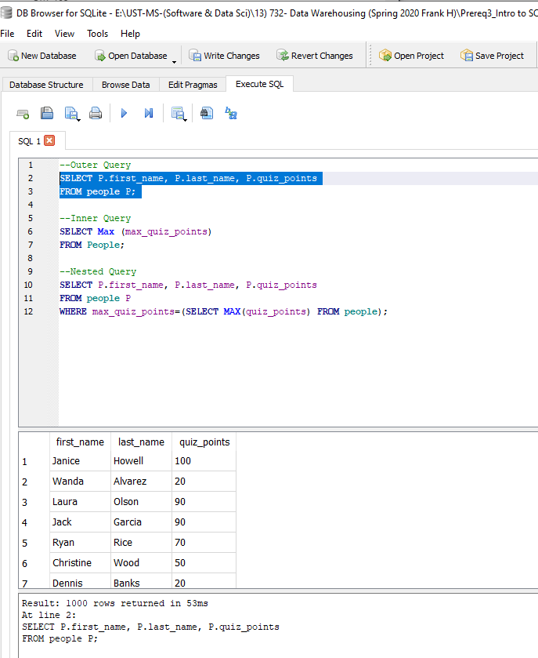

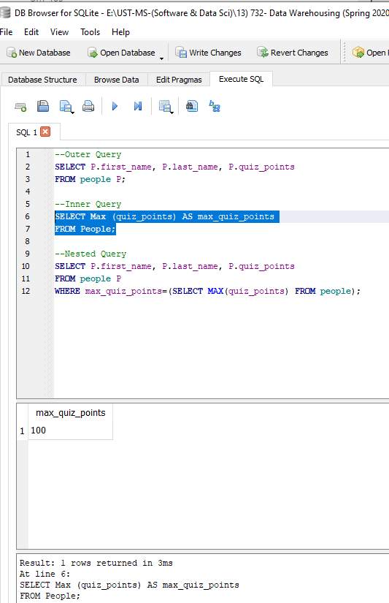

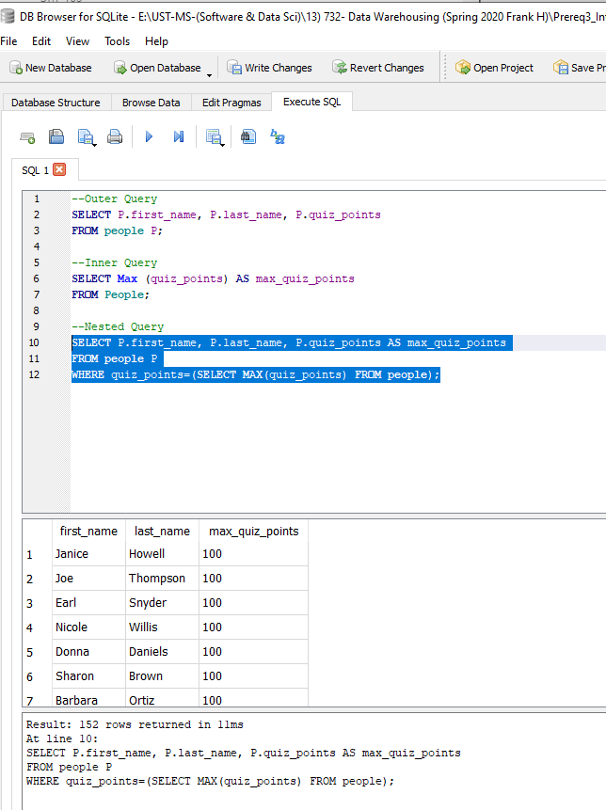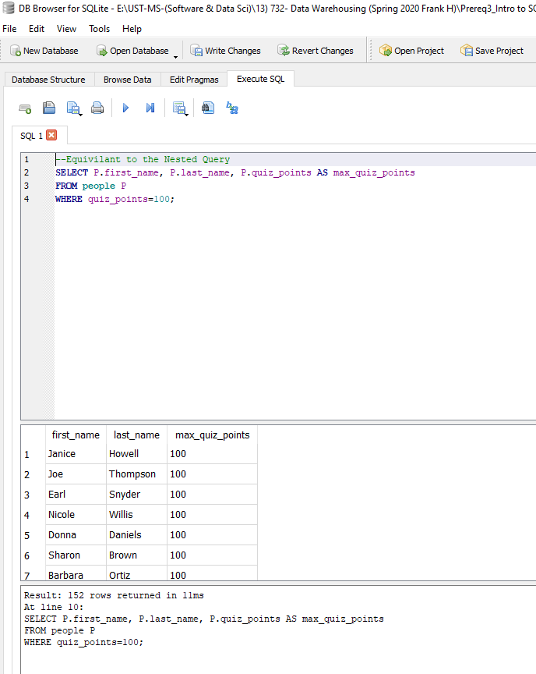

## 3.3 Chapter Quiz

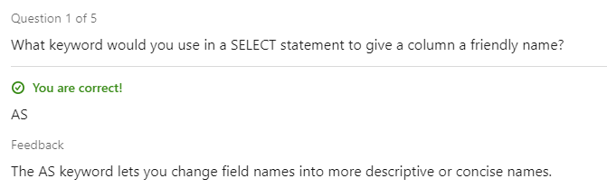

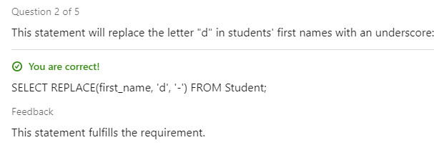

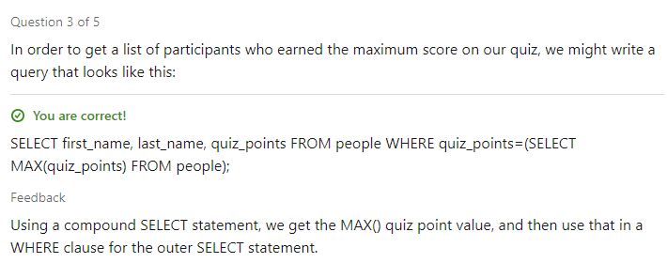

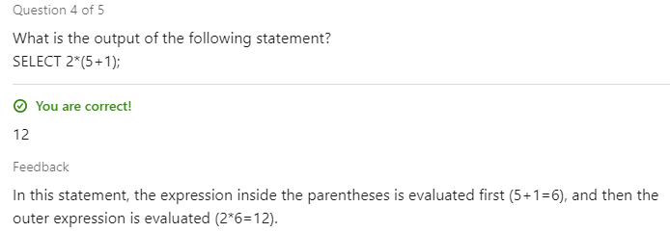

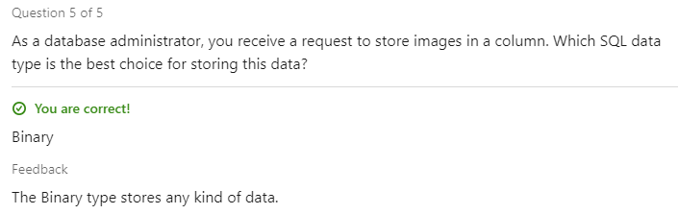

# 4.Ask Database to add or modify data

## 4.1 Add data to a table

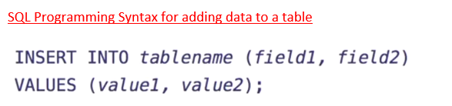 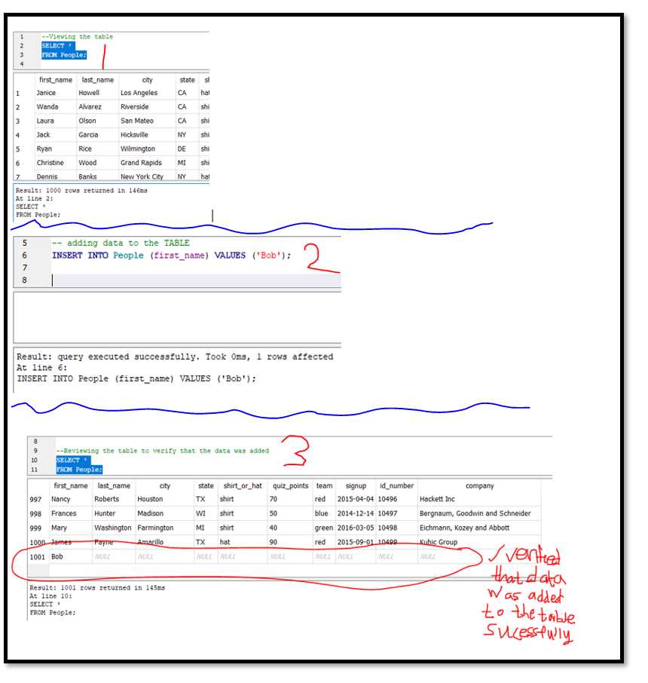

## 4.2 Updating data in a table

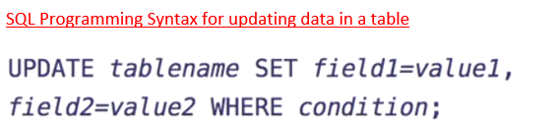

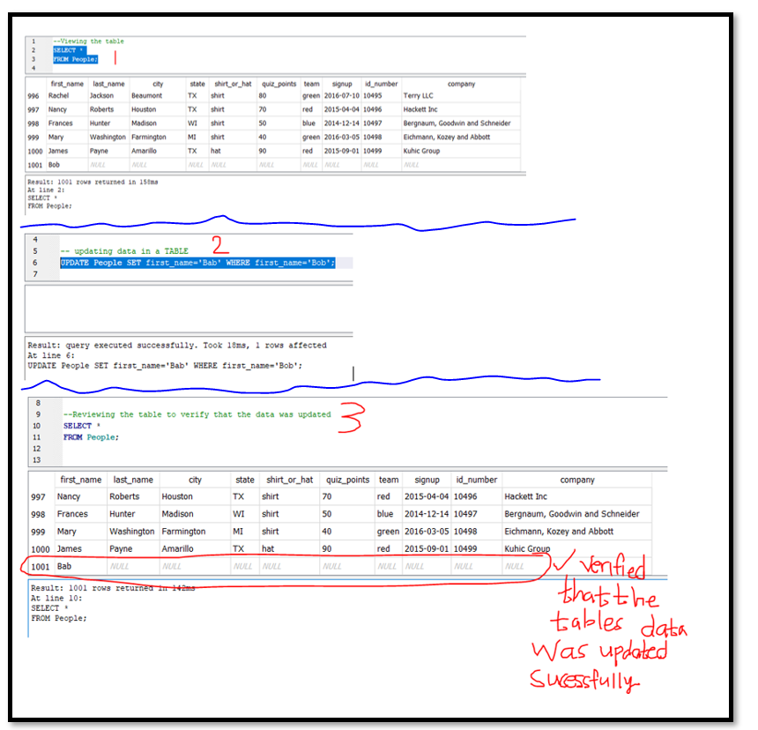

## 4.3 Remove data from a table



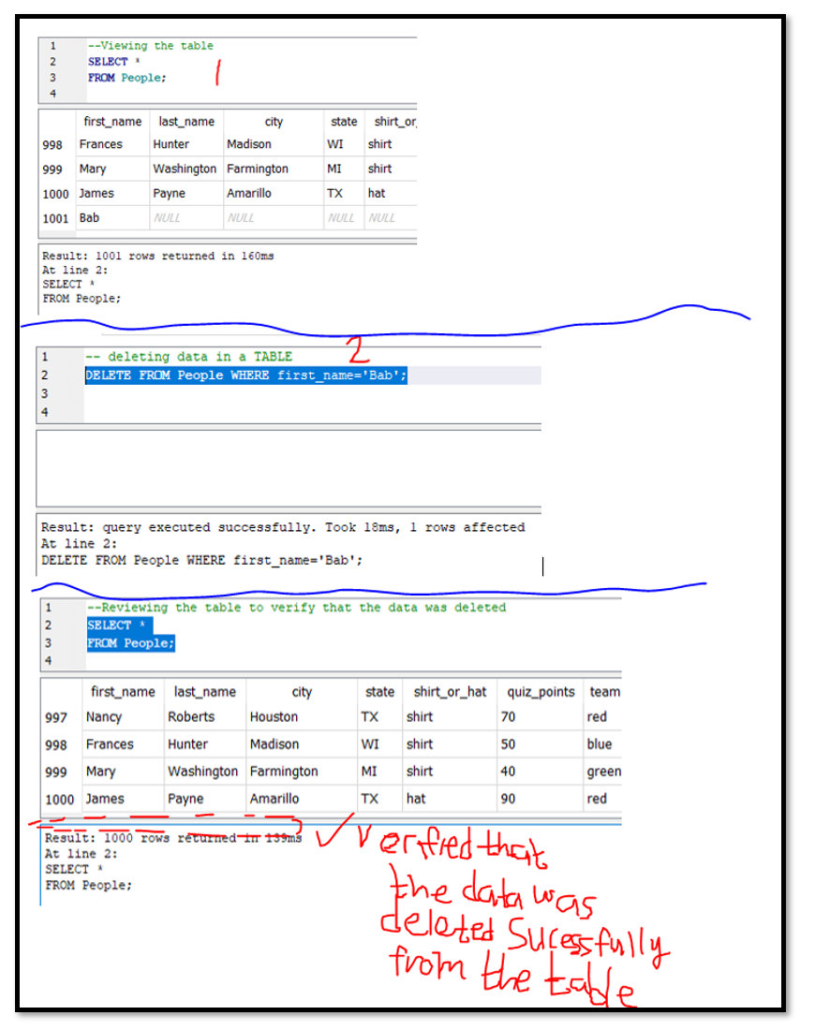

## 4.4 Chapter Quiz

# 

# 5. Conclusion

## 5.1 List of Common SQL Mistakes

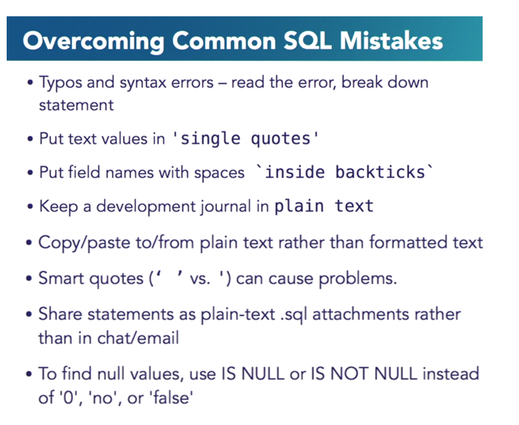

## 5.2 Chapter Quiz

